# Notification Screens Mock Up for Comment

Screen 1 Initial Page

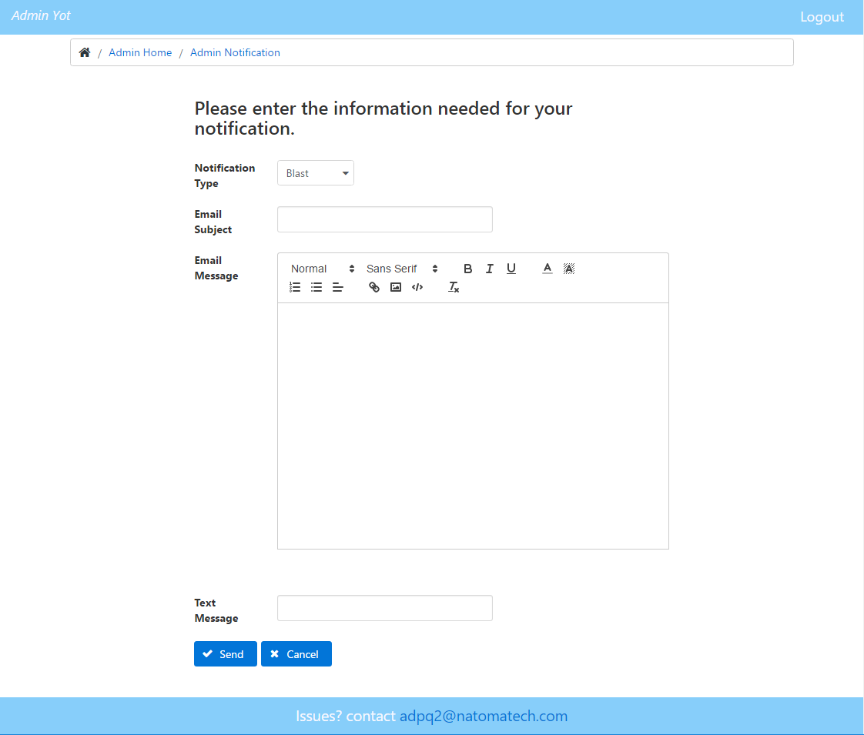

Screen 2 Enhanced Page After User Review

